

**Activating DoubleClue Autofill for Android**

**Version: 2.4.2**

Contents

1. Introduction 3

2. Enabling DoubleClue as Android Autofill App 3

3. Trouble Shooting 6

# Introduction

The autofill feature of the DoubleClue Android app allows users to insert their login credentials directly into other apps and homepages. It is supported as off Android version 9 or newer and partially supported in Android 8. Please be aware that singular apps might not support autofill.

# Enabling DoubleClue as Android Autofill Service

On most new Android devices, autofill will per default be active. However, the app chosen to handle autofill will be pre-set by the manufacturer. You can change this in the settings of your device.

**The exact names and locations may vary slightly depending on your device and android version.** This guide was created using a Google Pixel 4 with Android version 10.

1. Open Your Device Settings

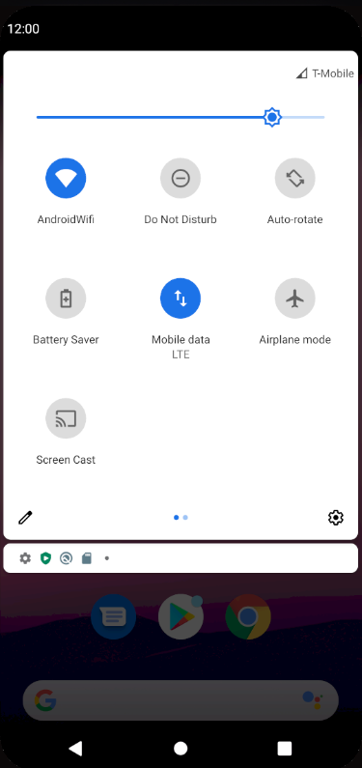

1. Enter “Autofill” into the Search Window
2. Choose “Autofill Service” under System > Languages & Input > Autofill Service among the displayed options.

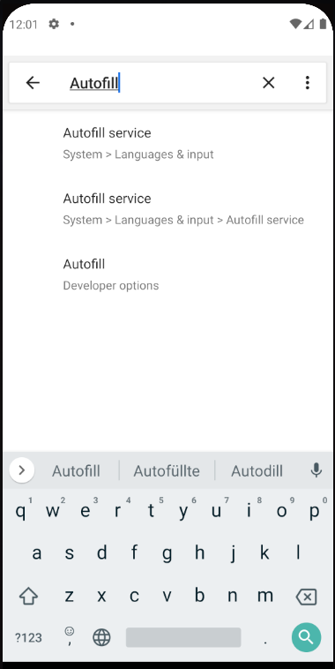

1. You will see the currently selected ‘Autofill Service’. Click on the field where the service is entered.

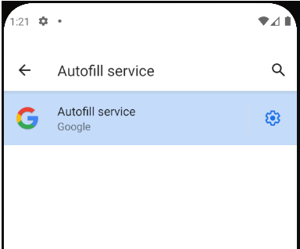

1. Select DoubleClue on the list of available Autofill services.

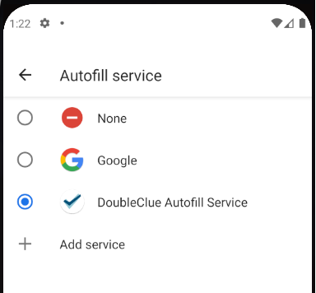

1. You will see a warning dialog that asks you whether you trust DoubleClue. Confirm this request.
2. Open an app or homepage and click into the name or password field. After a few moments, a menu will pop up, through which you can access the DoubleClue PasswordSafe.

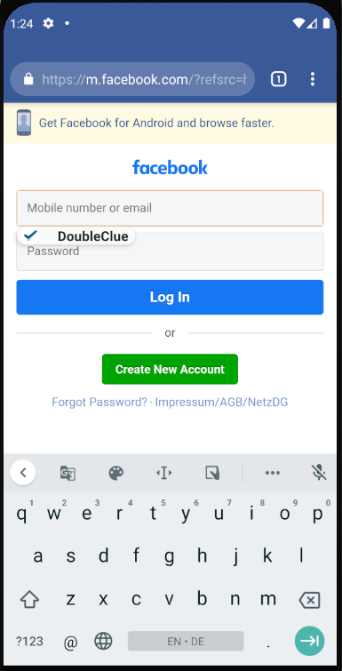

# Trouble Shooting

If you encounter any problems, please try the following before you contact your administrator or the DoubleClue support.

The menu doesn’t appear (neither in Apps nor in a browser)

Open the DoubleClue app. Then go to PasswordSafe and open the file, from which you want to take the credentials. Then return to the app or browser and click into the ‘Username’ or ‘Password’ window. Wait a few seconds. It may take a moment before the DoubleClue popup appears.

The menu doesn’t appear in a browser (eg. Chrome)

Empty the cache of your browser. If you use Chrome, you can do this by navigating to the Chrome icon on your device. Click on the icon and hold it until the options menu is displayed. Select ‘App Info’. Click on “Force stop” and then select “Storage & cache”. Here you will find the options to delete the cache. Start Chrome anew and try again to use DoubleClue autofill.

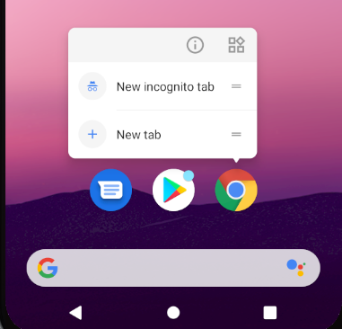 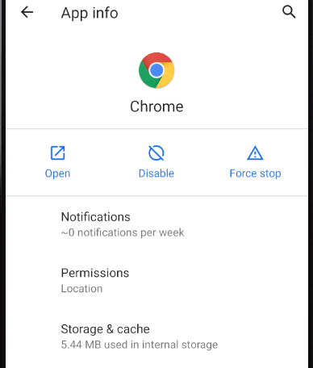

The menu doesn’t appear in a specific app

Not all apps support autofill. Please check the side of the app developer to find more information.